Syllabus for BCB 718 – Spring 2023
Computational Modeling Laboratory
Instructor: Jeremy Purvis MEJ 11018C jeremy_purvis@med.unc.edu
Co-Instructor: Adam Palmer MEJ 11202A palmer@unc.edu
Teaching Assistant: Jin Seok Lee (Andy) MEJ 11202 ajslee@unc.edu
Meeting Place/Time: Tuesdays and Thursdays at 2:00 PM in Marsico 2004
This course provides a practical introduction to computational modeling of biological systems. We will focus on how to choose and implement different modeling techniques—deterministic, stochastic, or inferred—and will use the same biological pathway as a case study throughout the course. No formal mathematical or computational background is required. Homework assignments will involve programming in MATLAB.
I. Deterministic Modeling
Assigned Reading: Sneyd, 2002 and Aldridge, 2006
Thursday, February 16: Introductions; quiz; short lecture on modeling; introduction to the IP₃ receptor; set office hours with Andy; assigned readings
Thursday, February 23: How to go from cartoons to equations; ODE modeling; begin homework 1
II. Stochastic Modeling
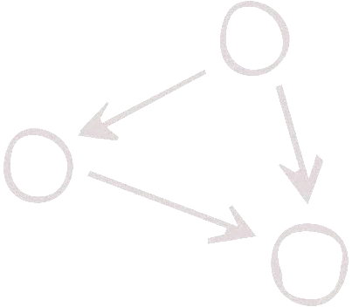
Assigned Reading: Gillespie, 1977 and Gillespie 2007
Tuesday, February 28: Introduction to stochastic systems
Thursday, March 2: Homework 1 due; Gillespie algorithm; introduce final assignment; Begin
Homework 2
III. Parameters
Assigned Reading: Gunawardena, 2009
Tuesday, March 7: Introduction to parameter fitting; form groups for final project
Thursday, March 9: Homework 2 due; Lecture on sensitivity analysis; Begin Homework 3.
IV. Modeling Applications
Assigned Reading: Stein, 2019
Tuesday, March 21: Modeling variability in populations
Thursday, March 23: Model Inference (paper discussion)
V. Student Presentations
Assigned Reading: Bromberg, 2008
Tuesday, March 28: Homework 3 due; Example modeling project; genetic algorithms for parameter estimation.
Thursday, March 30: Student Presentations
Grades will be assigned based on four equally weighted assignments. The first three assignments will have a set of standard questions and one challenge question. The final assignment is an open-ended project where students will model a biological system of their choice using any of the approaches presented in class. Students will work in pairs and must select their model systems by March 9. The model can be focused on a pathway related to your thesis or rotation work, or another biological system of interest. A course grade of high pass is reserved for students that consistently provide acceptable answers to the challenge questions and produce a high-quality final assignment.

